**Tennis Elbow**

**Initial Assessment**

|  |  |  |
| --- | --- | --- |
| **Presenting Symptom/Chief Complaint** | | |
| Patient is complaining of acute painful syndrome to the both elbows due to sport injury and repetitive movement at the work. | | |
| **Main Signs and Symptoms** | | |
| Pain is severe with limitations of arm and wrist movements, tingling and numbness along the arms and fingertips. | | |
| **Other Signs and Symptoms** | | |
| Otherwise patient is healthy. | | |
| **TCM Diagnosis and Treatment (identified TCM disease, TCM differentiation of syndromes)** | | |
| Acute painful obstruction syndrome in both elbow areas due to damp-cold invasion and overextension of the joints. | | |
| **Treatment Principles and Strategies** | | |
| Remove the dampness. Expel cold. Restore the Qi movement at the main channel. Remove Qi obstruction. | | |
| **Treatment Plan (Modalities; acupuncture, herbal, dietary, manual therapies), frequency and duration** | | |
| Acupuncture with distal joints sedation and local joints tonification with session duration of 1 hour every 2-3 days, till the symptoms resolved. | | |
| **Any other Advice Given to Patients** | | |
| Acupuncture: Distal points L1(1)(L,R) LI4(LR) TW5(bilateral) . Tw 5 with strong stimulation on both sides. Local points. LI11(bilateral) preferable tonification for 1 hour-relieve painful obstruction syndrome. QU yang WEI-extra point (bilateral) (specific point for tennis elbow)  TW10 –tip of olecranon. LI12(to prevent upward radiation of pain).Needling the connecting joints of channels on the opposite side (Ue6) bilaterally, (Ue5) bilaterally-relax tendons of the arms. | | |
| **Practitioner:** | **Date:** | **Signature:** |

**Tennis Elbow**

**Daily Charting____________________________________Patient Name:**

**Date:**

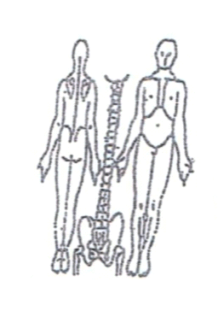**Working Diagnosis:** Painful obstruction syndrome in both elbow area caused by combination of extension of elbow joints.

S: Patient is complaining of acute sudden episode of pain at night and disturbing the sleep. Pain radiated to the lateral side of arms. Numbness and tingling along the arms.

O:

Treatment (P) Acupuncture: Distal points L1(1)(L,R) LI4(LR) TW5(bilateral) . Tw 5 with strong stimulation on both sides. Local points. LI11(bilateral) preferable tonification for 1 hour-relieve painful obstruction syndrome. QU yang WEI-extra point (bilateral) (specific point for tennis elbow). TW10 –tip of olecranon. LI12(to prevent upward radiation of pain).Needling the connecting joints of channels on the opposite side (Ue6) bilaterally, (Ue5) bilaterally-relax tendons of the arms.

(A) Acupuncture 1 hour due to treatment.

**Date:**

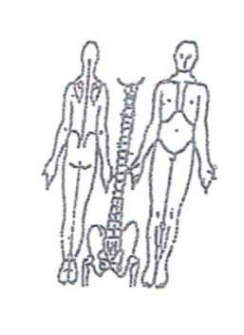**Working Diagnosis:**

S: Patient still having pain in both arms. Tired and low energy during the day. Pain at night time and sleepless night.

O:

Treatment (P) Acupuncture with Moxibustion – 1 hour according to the protocol.

(A)

**Date:**

**Working Diagnosis:**

S: Pain is , ROM. Can work on the computer with wrist support. N sleep. level of energy.

O:

Treatment (P) Acupuncture with tonification 1 hour as per protocol.

(A)

**Date:**

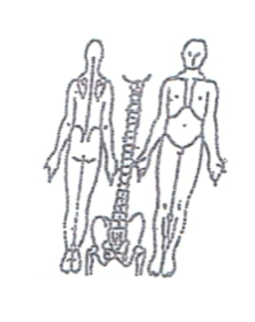**Working Diagnosis:**

S: Patient is feeling well. No pain bilaterally. N ROM. N daily activities and work. Starting the stretching exercises.

O:

Treatment (P) Acupuncture + Moxibustion – 1 hour according to the protocol.

(A)